REPORT DBMS FINAL PROJECT

Entity Relationship Diagram :-
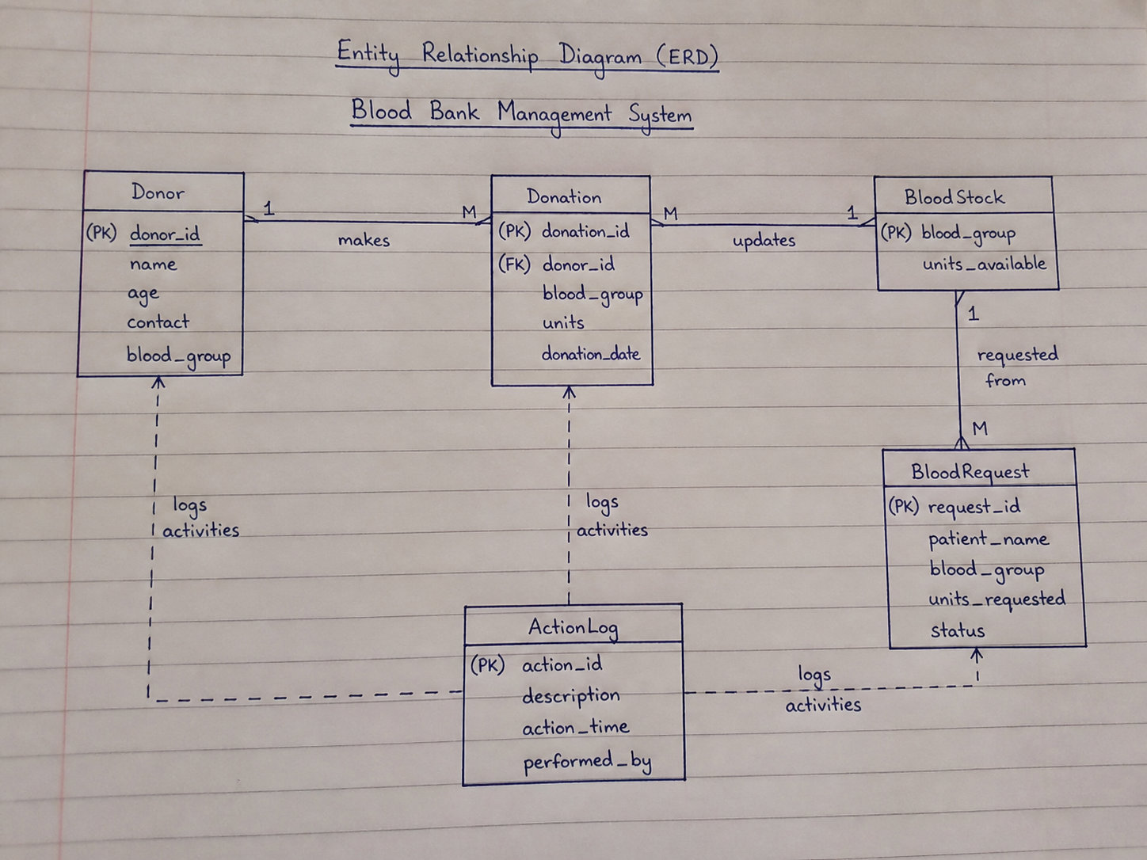

1. Core Schema Objects
This section describes the foundational elements of the BloodBankDB database.

1.1 Tables and Fields

Donor
- Donor_ID (INT, Primary Key)
- Name (VARCHAR(100))
- Age (INT)
- Contact (VARCHAR(20))
- Blood_Group (VARCHAR(5))
Purpose: Stores donor personal information.

BloodStock
- Blood_Group (VARCHAR(5), Primary Key)
- Units_Available (INT)
Purpose: Stores available blood units.

Donation
- Donation_ID (INT, Primary Key)
- Donor_ID (INT, Foreign Key referencing Donor)
- Blood_Group (VARCHAR(5))
- Units (INT)
- Donation_Date (DATE)
Purpose: Stores donation history.

BloodRequest
- Request_ID (INT, Primary Key)
- Patient_Name (VARCHAR(100))
- Blood_Group (VARCHAR(5))
- Units_Requested (INT)
- Status (VARCHAR(20))
Purpose: Stores blood requests from patients.

ActionLog
- Action_ID (INT, Primary Key)
- Description (VARCHAR(255))
- Action_Time (TIMESTAMP)
- Performed_By (VARCHAR(100))
Purpose: Tracks system activities.

1.2 Keys and Constraints
- Primary Keys: Each table has unique ID
- Foreign Keys:
  - Donation.Donor_ID → Donor
- Check Constraints:
  - Age > 18
  - Units > 0
- Unique Constraints:
  - Donor.Contact must be unique

1.3 Normalization (Up to 3NF)
The database is normalized up to Third Normal Form.

First Normal Form (1NF)
All tables contain atomic values (no repeating groups).

Second Normal Form (2NF)
Rule: Remove partial dependencies.

Identified Partial Dependencies:

- Donor details depend only on Donor_ID
- Donation details depend on Donation_ID
- Stock depends on Blood_Group

Decomposition into 2NF Tables:

Table A: Donor Table
Primary Key: Donor_ID
ID | Name | Age | Contact | Blood Group
1 | Ali Khan | 25 | 03001234567 | A+
2 | Ahmed Ali | 30 | 03111234567 | B+
3 | Sara Khan | 28 | 03221234567 | O-

Table B: Donation Table
Primary Key: Donation_ID
Donation ID | Donor ID | Blood Group | Units | Date
1 | 1 | A+ | 1 | 2026-01-01
2 | 2 | B+ | 2 | 2026-02-01
3 | 3 | O- | 1 | 2026-03-01

Table C: BloodStock Table
Blood Group | Units
A+ | 10
B+ | 8
O- | 5

Third Normal Form (3NF)
Rule: Remove transitive dependencies.

Identified Dependencies:

- No non-key attribute depends on another non-key attribute

Final 3NF Tables

Donor
Donor ID | Name | Age | Contact | Blood Group
1 | Ali Khan | 25 | 03001234567 | A+
2 | Ahmed Ali | 30 | 03111234567 | B+
3 | Sara Khan | 28 | 03221234567 | O-

BloodStock
Blood Group | Units Available
A+ | 10
B+ | 8
O- | 5

Donation
Donation ID | Donor ID | Blood Group | Units | Date
1 | 1 | A+ | 1 | 2026-01-01
2 | 2 | B+ | 2 | 2026-02-01
3 | 3 | O- | 1 | 2026-03-01

BloodRequest
Request ID | Patient | Blood Group | Units | Status
1 | Usman | A+ | 2 | Completed
2 | Zain | B+ | 1 | Pending

2. Queries and Implementation

2.1 Joins

Query 1: Retrieve Donor name along with donated blood details
SELECT Donor.name, Donation.blood_group, Donation.units
FROM Donor, Donation
WHERE Donor.donor_id = Donation.donor_id;

Explanation:
- This query uses an implicit INNER JOIN between Donor and Donation tables
- It matches records where donor_id is the same in both tables
- It retrieves:
  - Donor name
  - Blood group donated
  - Units donated

Purpose:
To display which donor donated how much blood and of which group.

2.2 Subqueries

Query 2: Retrieve donors who have made donations
SELECT name
FROM Donor
WHERE donor_id IN (
SELECT donor_id FROM Donation
);

Explanation:
- The inner query selects all donor IDs from the Donation table
- The outer query retrieves names of donors whose IDs exist in that list
Purpose:
To find donors who have actually donated blood (active donors).

2.3 Aggregation Functions

Query 3: Count total number of donations
SELECT COUNT(*) AS total_donations FROM Donation;

Explanation:
- COUNT(*) counts total rows in the Donation table
Purpose:
To know how many total donations have been made.

Query 4: Calculate total blood units available
SELECT SUM(units_available) AS total_units FROM BloodStock;

Explanation:
- SUM() adds all values of units_available
Purpose:
To calculate total blood stock available in the system.

2.4 Filtering Queries

Query 5: Retrieve donors with specific blood group
SELECT * FROM Donor
WHERE blood_group = 'A+';

Explanation:
- Filters donors having blood group A+
Purpose:
Useful when specific blood type is required.

2.5 Basic Retrieval Queries

Query 6: View all donors
SELECT * FROM Donor;
Displays all donor records

Query 7: View blood stock
SELECT * FROM BloodStock;
Displays available blood units

Query 8: View donation records
SELECT * FROM Donation;
Displays all donation history

Query 9: View blood requests
SELECT * FROM BloodRequest;
Displays all patient requests

GitHub Repository :
https://github.com/sanan91/MAHAD-DBMS-PROJECT-BLOOD-DONATION-SYSTEM.git

